### Chapter 1: Fundamentals

* What Is a Robot?
* Classification of Robots
* What Is Robotics?
* History of Robotics
* Advantages and Disadvantages of Robots
* Robot Components, Degrees of Freedom, Joints, Coordinates, Reference Frames
* Programming Modes, Robot Characteristics, Workspace, Languages, Applications
* Social Issues

### Chapter 2: Kinematics of Serial Robots: Position Analysis

* Robots as Mechanisms
* Conventions
* Matrix Representation & Homogeneous Transformation Matrices
* Forward and Inverse Kinematics (Position & Orientation)
* Denavit–Hartenberg Representation
* Inverse Kinematic Solutions, Programming, Degeneracy & Dexterity
* Design Projects, Summary, References, Problems

### Chapter 3: Differential Motions and Velocities

* Jacobian, Differential Relationships vs. Large Motions
* Differential Motions of Frame vs. Robot, Inverse Jacobian

### Chapter 4: Dynamic Analysis and Forces

* Lagrangian Mechanics, Inertia and Kinetic/Potential Energy
* Equations of Motion, Static Force Analysis, Frame Transformations

### Chapter 5: Trajectory Planning

* Path vs. Trajectory, Joint vs. Cartesian Space
* Polynomial Trajectories, Parabolic Blends, Via Points, Continuous Recording

### Chapter 6: Motion Control Systems

* Block Diagrams, System Dynamics, Laplace Transform, Transfer Functions
* Root Locus, Bode Analysis, PID Control, Lead/Lag Compensators, State‑Space & Digital Control, Nonlinear Control

### Chapter 7: Actuators and Drive Systems

* Hydraulics, Pneumatics, Electric Motors (DC/AC/Brushless/Servomotors), Magnetostrictive & Shape‑Memory Actuators, Electroactive Polymers, Speed Reduction Systems

### Chapter 8: Sensors

* Sensor Characteristics & Utilization
* Position, Velocity, Acceleration, Force, Torque, Proximity, Range, Vision, Voice, Taste/Smell Sensors

### Chapter 9: Image Processing & Analysis with Vision Systems

* Fourier Transform, Noise, Edge Detection, Segmentation, Morphology, Object Recognition, Depth Measurement, Compression, Lighting, Applications

### Chapter 10: Fuzzy Logic Control

* Fuzzy Sets, Membership, Fuzzification & Defuzzification, Rule Base, Simulation, Robotic Applications
* Design Project, Summary, References, Problems

## 1. ****What Is a Robot?****

A **robot** is a **programmable, multifunctional machine** designed to move and perform tasks by following commands or autonomous control systems.

Robots:

* Sense their environment (e.g., with cameras or sensors)
* Process information (via microcontrollers or AI)
* Act physically (through motors or actuators)

**Example**: Industrial robot arm, delivery drone, humanoid robot, robotic vacuum.

|  |  |
| --- | --- |
|  |  |
|  |  |

**2. Classification of Robots**

Robots can be classified by:

**A. Application**

* Industrial Robots – used in manufacturing (e.g., welding arms)
* Service Robots – healthcare, cleaning, delivery, etc.
* Exploration Robots – space rovers, underwater bots
* Military Robots – drones, bomb disposal units

**B. Kinematic Structure**

* Serial Manipulators – like a human arm (rigid links and joints in sequence)
* Parallel Robots – multiple arms control one platform (e.g., flight simulators)
* Mobile Robots – can move across terrain (e.g., wheeled or legged)

**C. Control Type**

* Teleoperated – controlled remotely by a human
* Autonomous – self-controlled based on sensing and programming
* Semi-autonomous – mix of both

**3. What Is Robotics?**

Robotics is the interdisciplinary field that: Designs, builds, and programs robots

Combines mechanical engineering, electrical/electronics, control theory, and computer science/AI

It includes:

* Kinematics & Dynamics (how robots move)
* Control systems (how to make robots follow paths)
* Perception (sensors, cameras)
* AI (planning, decision making)

**6. Robot Components, DOF, Joints, Coordinates, Frames**

**1. Components**

* Mechanical structure (arms, chassis)
* Actuators (motors)
* Sensors (vision, distance, force)
* Controller (microprocessor or computer)
* End-effector (gripper, tool)

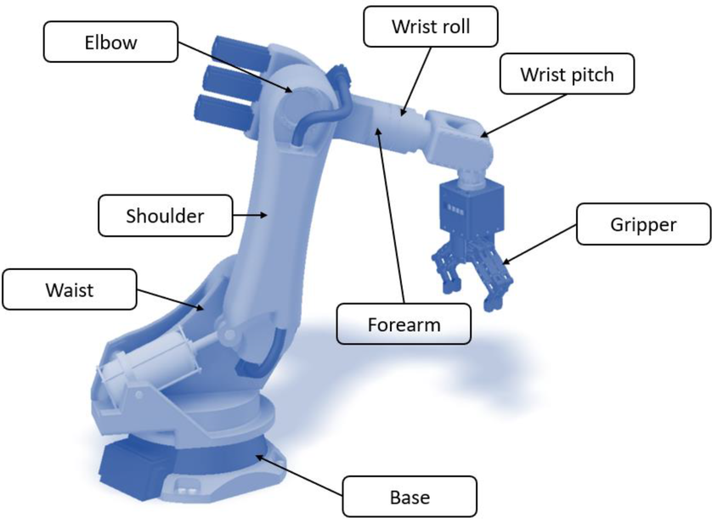

1. **Degrees of Freedom (DOF)**

Number of independent movements a robot can make

* A typical robotic arm may have 6 DOF (e.g., 3 for position, 3 for orientation)

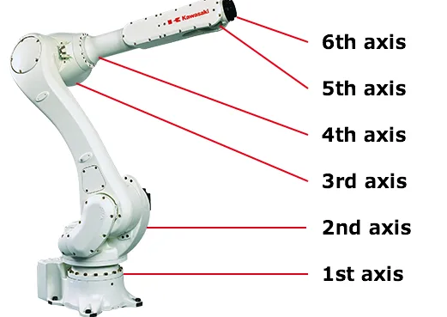

1. **Joints**

* Rotational (Revolute) – like a hinge (e.g., elbow)
* Prismatic – sliding motion (e.g., piston)

1. **Coordinates**

* Joint Space – angles/displacements at each joint
* Cartesian Space – X, Y, Z, Roll, Pitch, Yaw of end-effector

|  |  |  |
| --- | --- | --- |
|  |  |  |

1. **Reference Frames**

* Coordinate systems attached to each part of the robot (base, joint, tool), Used to calculate position/orientation using transformation matrices

**Chapter 2: Kinematics of Serial Robot: Position Analysis.**

Forward kinematics formulation is to find the position and orientation of the end-effector of a robot by knowing the values of its joint variables. The joint variables are angular position of the rotational joints ( θ j ) and linear displacement of prismatic joints ( d j ).

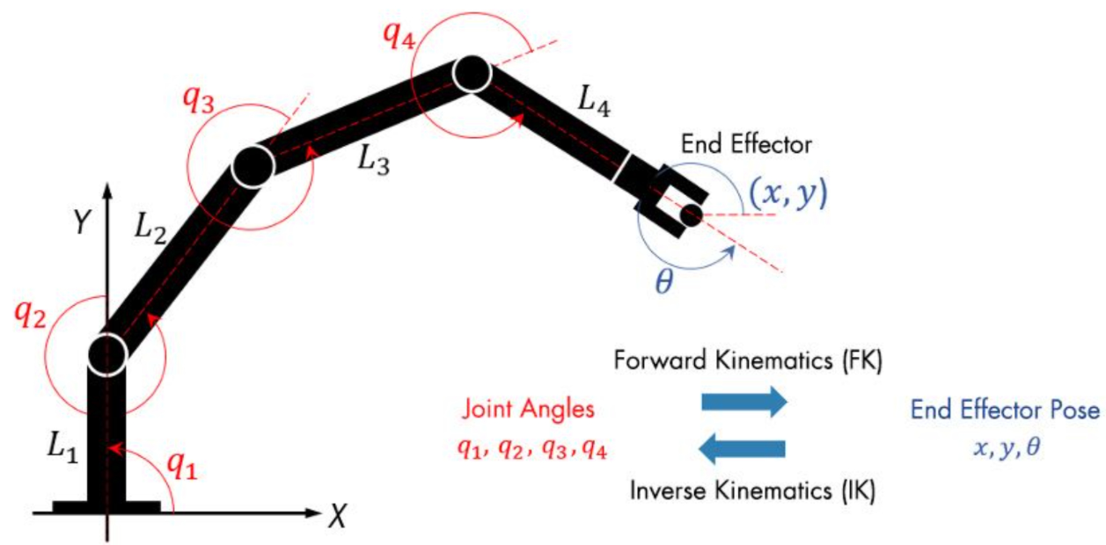

Inverse kinematics (IK) in robotics is the process of determining the joint parameters (angles, etc.) of a robot to achieve a desired end-effector position and orientation.

Robot as a mechanism will be discussed in a video

**Transformers**

Representation of a point in a space

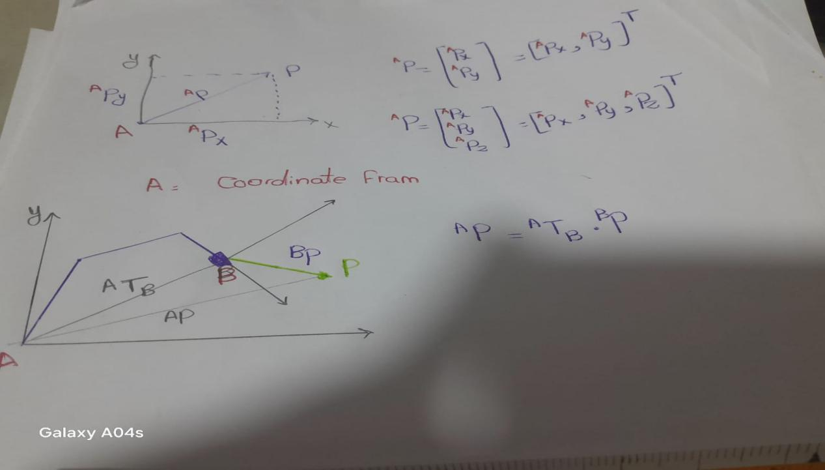

Representation of a point in a space